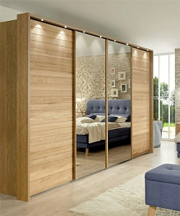

Universal cupboard

$172.15

Availability: In stock

Description

Modern wooden wardrobe with mirror sliding doors. This fabulous cupboard have 4 drawers with 2-mirrors in the Centre. Smooth surface with glass coting 8 by 6 height and width. High quality wood made cupboard with eight electric lights option.